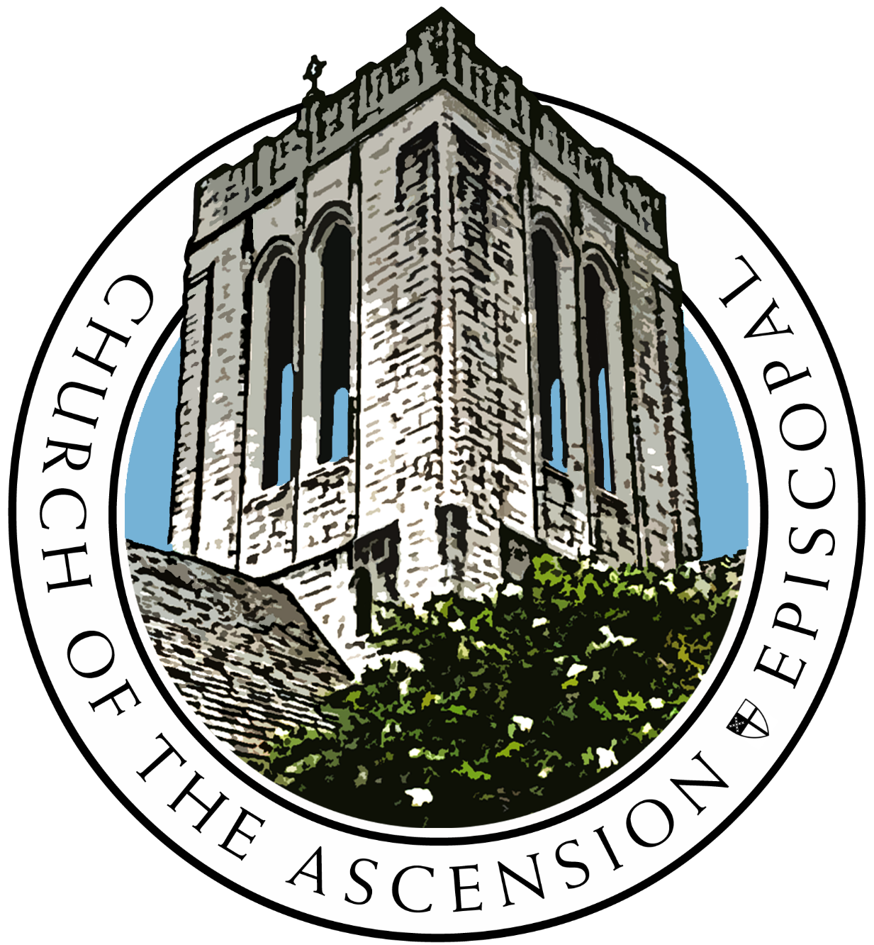

Church of the Ascension
We believe in sharing love and grace by seeking relationship with God and one another.

First Sunday in Advent
Sunday, November 28th, 2021
The Reverend Candice B. Frazer, Rector
The Reverend Andrew S. Brislin, Associate Rector

Organist/ Choirmaster: Rebecca B. Taylor
Lector: Ellen Brooks
LEMs: Bill Cunningham
and Laura Mielke
Verger: Bill Garrett
Acolytes: Kayla Bledsoe

Ushers: Philip Goodwyn, Winston
Sheehan, and Don Vaughn
Altar Guild: Cara Coreale
and Susan Copeland
AV Crew:
Riley Harrison, Russel Bush, Sound
Peter Waldo, Camera

Holy Eucharist Rite I 10:30 AM Livestream

Voluntary: Chorale Prelude on “Wachet auf” (J. S. Bach)
Lighting of the Advent Wreath: Hymn 56, verses 1 and 2
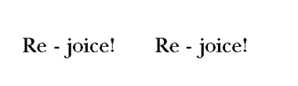
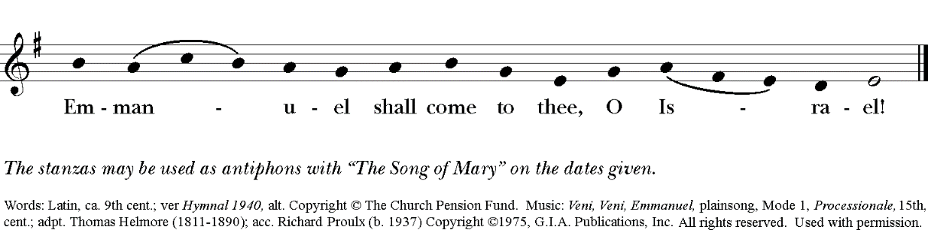

Hymn 57: Lo! he comes, with clouds descending (Helmsley)
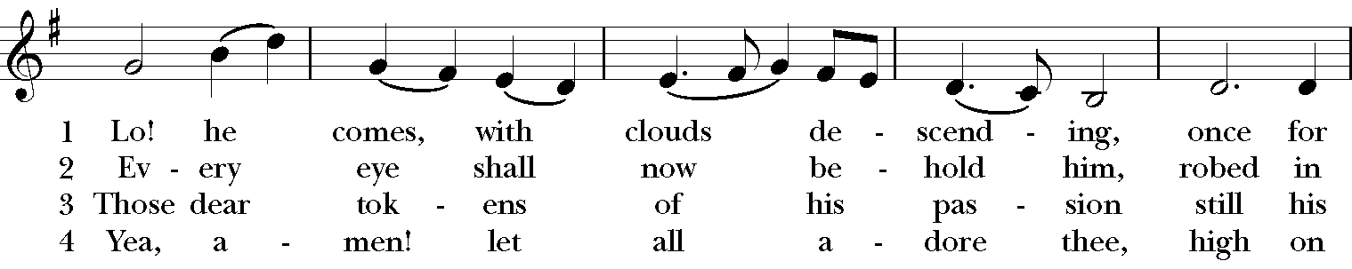
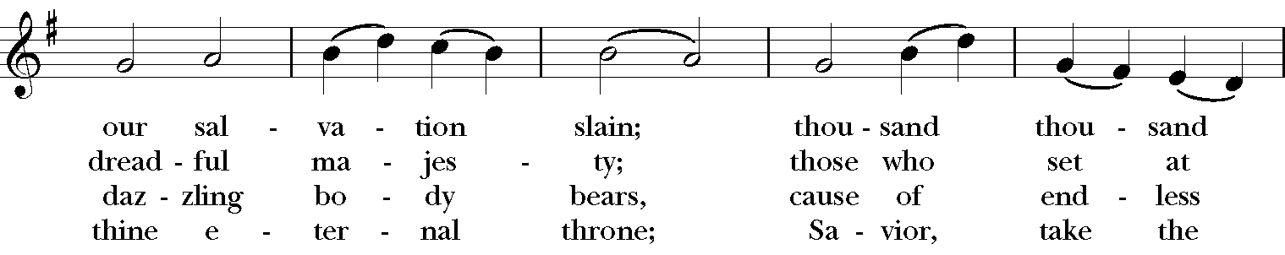
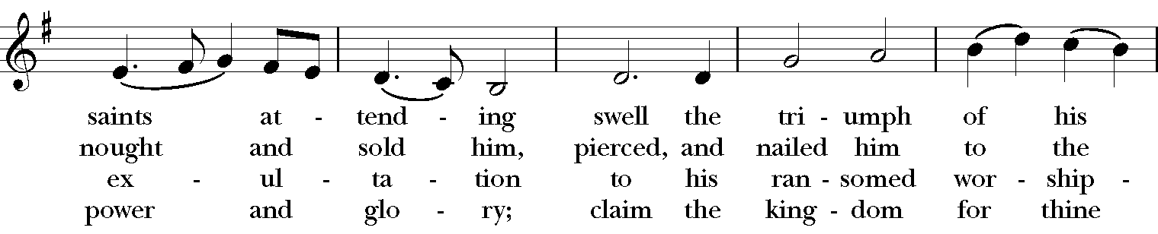
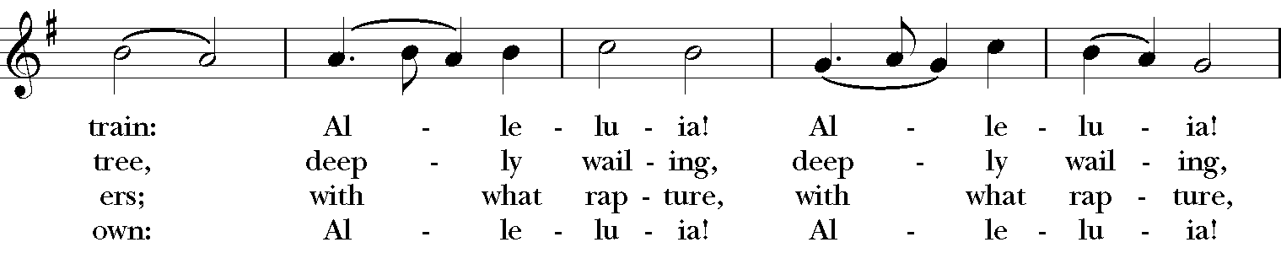
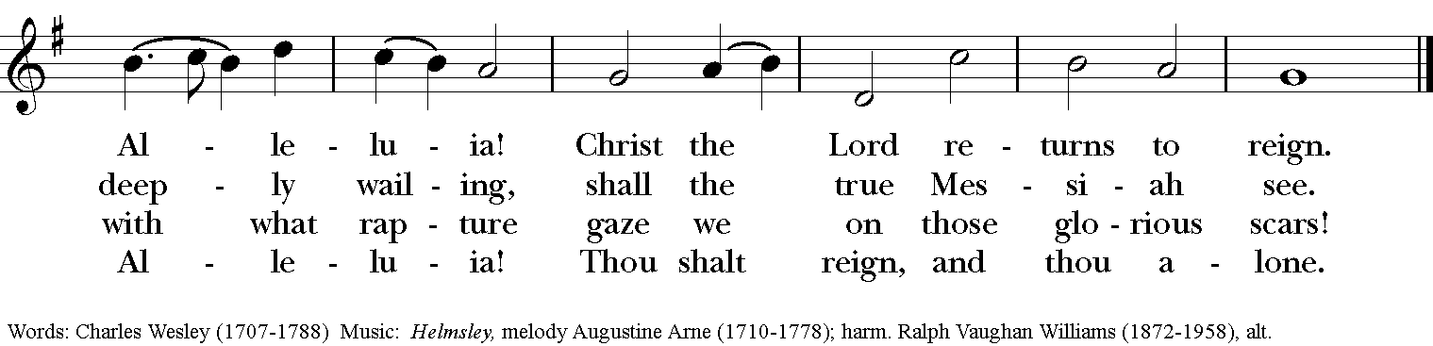

Officiant Blessed be God: Father, Son, and Holy Spirit. BCP 323
People And blessed be his kingdom, now and for ever. Amen.

The Celebrant then continues,
There is one Body and one Spirit;
People There is one hope in God’s call to us;
Celebrant One Lord, one Faith, one Baptism
People One God and Father of all

Celebrant The Lord be with you.
People And also with you.
Celebrant Let us pray/

Collect of the Day
Celebrant The Lord be with you.
People And also with you.
Celebrant Let us pray.

Almighty God, give us grace to cast away the works of darkness, and put on the armor of light, now in the time of this mortal life in which your Son Jesus Christ came to visit us in great humility; that in the last day, when he shall come again in his glorious majesty to judge both the living and the dead, we may rise to the life immortal; through him who lives and reigns with you and the Holy Spirit, one God, for ever and ever. Amen.

First Reading Jeremiah 33:14-16
A Reading from Jeremiah.

The days are surely coming, says the Lord, when I will fulfill the promise I made to the house of Israel and the house of Judah. In those days and at that time I will cause a righteous Branch to spring up for David; and he shall execute justice and righteousness in the land. In those days Judah will be saved and Jerusalem will live in safety. And this is the name by which it will be called: "The Lord is our righteousness."

Reader The Word of the Lord.
People Thanks be to God.

Psalm 25:1-9 Ad te, Domine, levavi 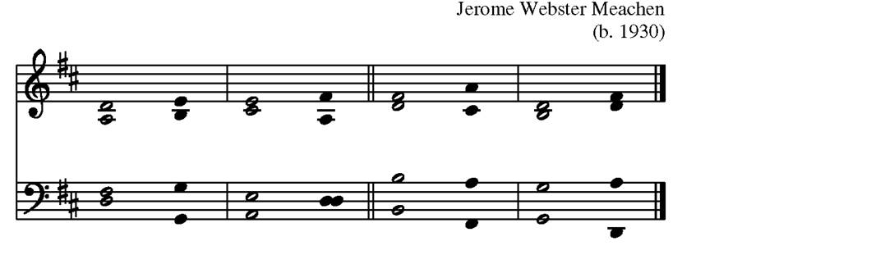
A B

1 To you, O LORD, I lift up my soul;
my God, I put my trust in / you; *
let me not be humiliated,
nor let my enemies triumph / over me.
2 Let none who look to you be put to / shame; *
let the treacherous be disappointed in their / schemes.

3 Show me your ways, O / LORD, *
and teach me your / paths.
4 Lead me in your truth and / teach me, *
for you are the God of my salvation;
in you have I trusted all the day / long.

5 Remember, O LORD, your compassion and / love, *
for they are from ev-er- / lasting.
6 Remember not the sins of my youth and my trans- / gressions; *
remember me according to your love
and for the sake of your goodness, O / LORD.

7 Gracious and upright is the / LORD; *
therefore he teaches sinners in his / way.
8 He guides the humble in doing / right *
and teaches his way to the / lowly.

9 All the paths of the LORD are love and / faithfulness *
to those who keep his covenant and his tes-ti- / monies.

Second Reading 1 Thessalonians 3:9-13

A reading from the book of Thessalonians.

How can we thank God enough for you in return for all the joy that we feel before our God because of you? Night and day we pray most earnestly that we may see you face to face and restore whatever is lacking in your faith.
Now may our God and Father himself and our Lord Jesus direct our way to you. And may the Lord make you increase and abound in love for one another and for all, just as we abound in love for you. And may he so strengthen your hearts in holiness that you may be blameless before our God and Father at the coming of our Lord Jesus with all his saints.
Reader The Word of the Lord.
People Thanks be to God.

Hymn 61 “Sleepers, wake!” A voice astounds us (Wachet auf)
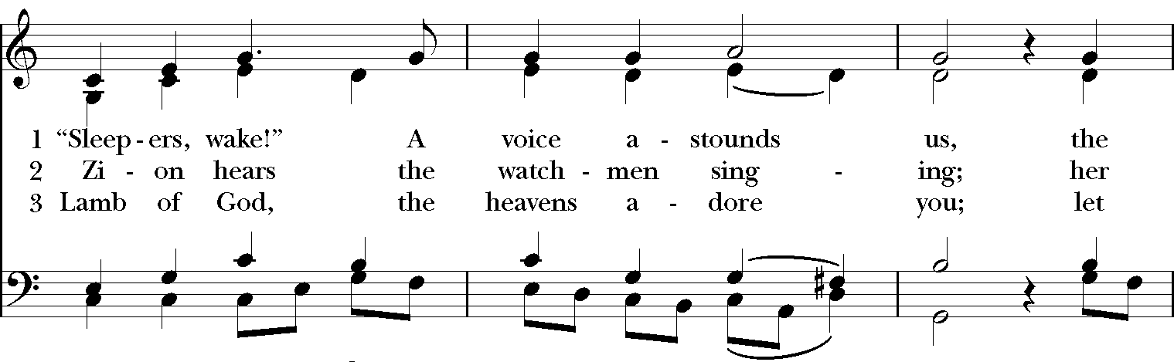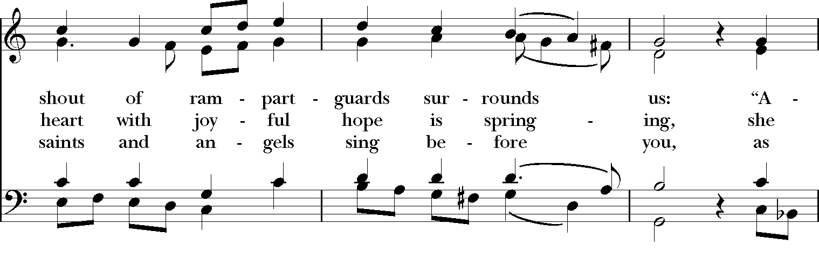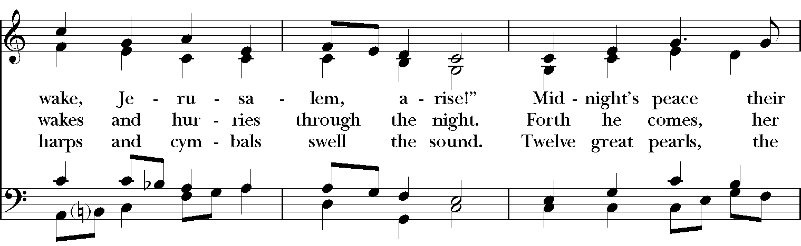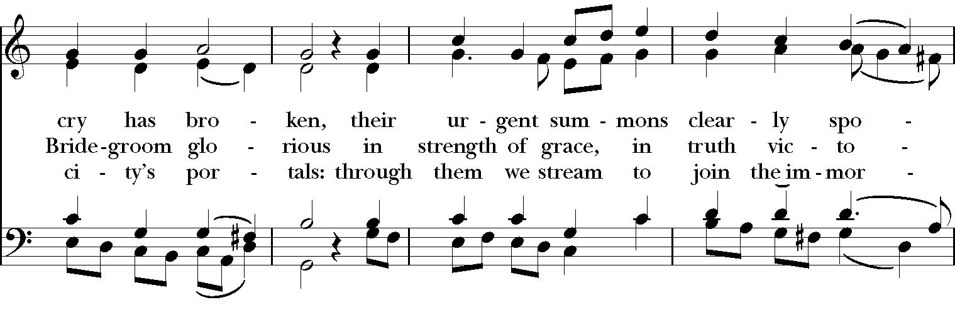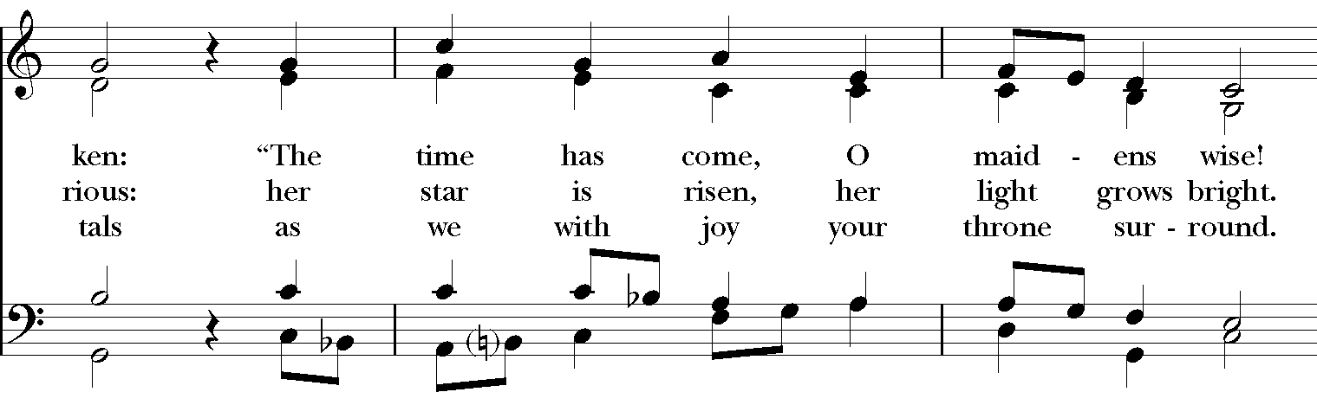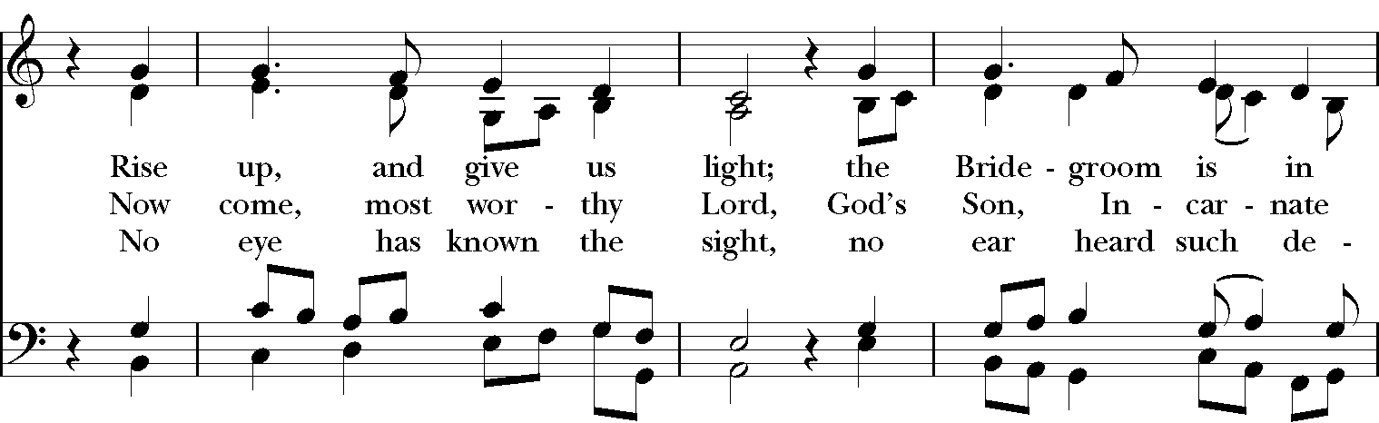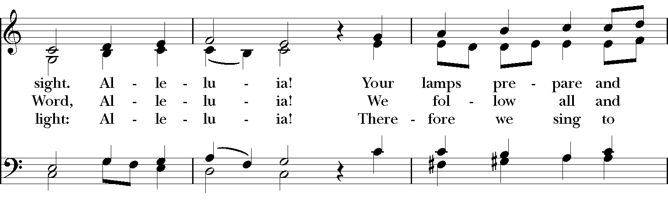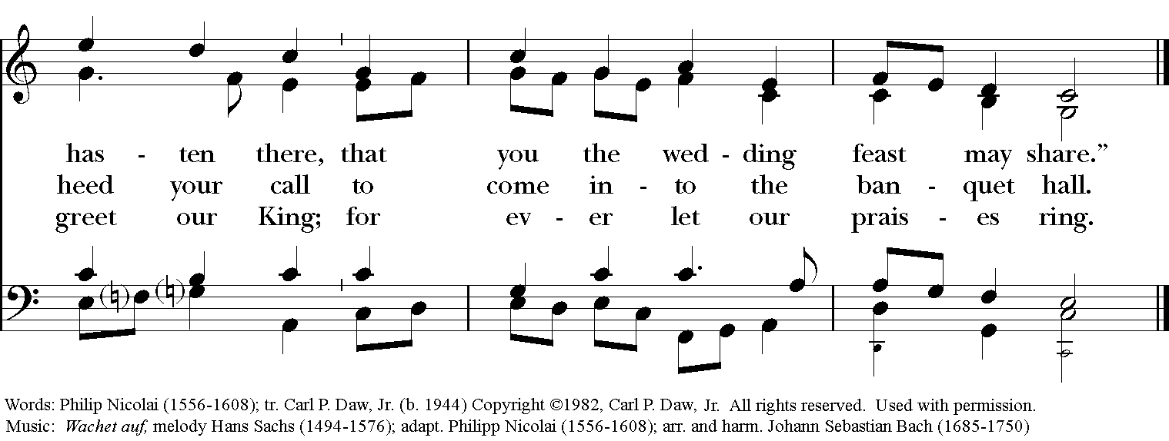

Holy Gospel Luke 21:25-36
Celebrant The Holy Gospel of our Lord Jesus Christ according to Luke.
People Glory to you, Lord Christ.

Jesus said, "There will be signs in the sun, the moon, and the stars, and on the earth distress among nations confused by the roaring of the sea and the waves. People will faint from fear and foreboding of what is coming upon the world, for the powers of the heavens will be shaken. Then they will see 'the Son of Man coming in a cloud' with power and great glory. Now when these things begin to take place, stand up and raise your heads, because your redemption is drawing near."

Then he told them a parable: "Look at the fig tree and all the trees; as soon as they sprout leaves you can see for yourselves and know that summer is already near. So also, when you see these things taking place, you know that the kingdom of God is near. Truly I tell you, this generation will not pass away until all things have taken place. Heaven and earth will pass away, but my words will not pass away.

"Be on guard so that your hearts are not weighed down with dissipation and drunkenness and the worries of this life, and that day catch you unexpectedly, like a trap. For it will come upon all who live on the face of the whole earth. Be alert at all times, praying that you may have the strength to escape all these things that will take place, and to stand before the Son of Man."

Celebrant The Gospel of the Lord.
People Praise to you, Lord Christ.

Sermon The Rev. Candice B. Frazer

Presentation and Examination of Candidates
The Celebrant says
The Candidate(s) for Holy Baptism will now be presented.

Parents and Godparents
I present N. to receive the Sacrament of Baptism.

When all have been presented the Celebrant asks the parents and godparents
Will you be responsible for seeing that the child you present is brought up in the Christian faith and life?

Parents and Godparents
I will, with God’s help.

Celebrant
Will you by your prayers and witness help this child to grow into the full stature of Christ?

Parents and Godparents
I will, with God’s help.

Then the Celebrant asks the following questions of the candidates who can speak for themselves, and of the parents and godparents who speak on behalf of the infants and younger children

Question | Do you renounce Satan and all the spiritual forces of wickedness that rebel against God?
Answer | I renounce them.
Question | Do you renounce the evil powers of this world which corrupt and destroy the creatures of God?
Answer | I renounce them.
Question | Do you renounce all sinful desires that draw you from the love of God?
Answer | I renounce them.
Question | Do you turn to Jesus Christ and accept him as your Savior?
Answer | I do.
Question | Do you put your whole trust in his grace and love?
Answer | I do.
Question | Do you promise to follow and obey him as your Lord?
Answer | I do.

Celebrant addresses the congregation, saying
Will you who witness these vows do all in your power to support these persons in their life in Christ?

People We will.

The Celebrant then says these or similar words
Let us join with those who are committing themselves to Christ and renew our own baptismal covenant.

The Baptismal Covenant
Celebrant | Do you believe in God the Father?
People | I believe in God, the Father almighty,  creator of heaven and earth.
Celebrant | Do you believe in Jesus Christ, the Son of God?
People | I believe in Jesus Christ, his only Son, our Lord.  He was conceived by the power of the Holy Spirit  and born of the Virgin Mary.  He suffered under Pontius Pilate,  was crucified, died, and was buried.  He descended to the dead.  On the third day he rose again.  He ascended into heaven,  and is seated at the right hand of the Father.  He will come again to judge the living and the dead.
Celebrant | Do you believe in God the Holy Spirit?
People | I believe in the Holy Spirit,  the holy catholic Church,  the communion of saints,  the forgiveness of sins,  the resurrection of the body,  and the life everlasting.
Celebrant | Will you continue in the apostles’ teaching and fellowship, in the breaking of bread, and in the prayers?
People | I will, with God’s help.
Celebrant | Will you persevere in resisting evil, and, whenever you fall into sin, repent and return to the Lord?
People | I will, with God’s help.
Celebrant | Will you proclaim by word and example the Good News of God in Christ?
People | I will, with God’s help.
Celebrant | Will you seek and serve Christ in all persons, loving your neighbor as yourself?
People | I will, with God’s help.
Celebrant | Will you strive for justice and peace among all people, and respect the dignity of every human being?
People | I will, with God’s help.

Prayers for the Candidates
The Celebrant then says to the congregation
Let us now pray for this person who is to receive the Sacrament of new birth.
A Person appointed leads the following petitions
Leader | Deliver N., O Lord, from the way of sin and death.
People | Lord, hear our prayer.
Leader | Open his heart to your grace and truth.
People | Lord, hear our prayer.
Leader | Fill him with your holy and life-giving Spirit.
People | Lord, hear our prayer.
Leader | Keep him in the faith and communion of your holy Church.
People | Lord, hear our prayer.
Leader | Teach him to love others in the power of the Spirit.
People | Lord, hear our prayer.
Leader | Send him into the world in witness to your love.
People | Lord, hear our prayer.
Leader | Bring him to the fullness of your peace and glory.
People | Lord, hear our prayer.

The Celebrant says
Grant, O Lord, that all who are baptized into the death of Jesus Christ your Son may live in the power of his resurrection and look for him to come again in glory; who lives and reigns now and for ever. Amen.

Hymn 296 We know that Christ is raised and dies no more (Engelburg)

We know that Christ is raised and dies no more

embraced by death he broke its fearful hold;

and our despair he turned to blazing joy. Alleluia!

We share by water in his saving death.

Reborn we share with him an Easter life

as living members of a living Christ. Alleluia!

The Father’s splendor clothes the Son with life.

The Spirit’s power shakes the Church of God.

Baptized we live with God, the Three in One. Alleluia!

A new creation comes to life and grows

as Christ’s new body take on flesh and blood.

The universe restored and whole will sing: Alleluia! Amen.

Thanksgiving over the Water
The Celebrant blesses the water, first saying
 | The Lord be with you.
People | And also with you.
Celebrant | Let us give thanks to the Lord our God.
People | It is right to give him thanks and praise.

Celebrant
We thank you, Almighty God, for the gift of water. Over it the Holy Spirit moved in the beginning of creation. Through it you led the children of Israel out of their bondage in Egypt into the land of promise. In it your Son Jesus received the baptism of John and was anointed by the Holy Spirit as the Messiah, the Christ, to lead us, through his death and resurrection, from the bondage of sin into everlasting life.

We thank you, Father, for the water of Baptism. In it we are buried with Christ in his death. By it we share in his resurrection. Through it we are reborn by the Holy Spirit. Therefore in joyful obedience to your Son, we bring into his fellowship those who come to him in faith, baptizing them in the Name of the Father, and of the Son, and of the Holy Spirit.

At the following words, the Celebrant touches the water
Now sanctify this water, we pray you, by the power of your Holy Spirit, that those who here are cleansed from sin and born again may continue for ever in the risen life of Jesus Christ our Savior.

To him, to you, and to the Holy Spirit, be all honor and glory, now and for ever. Amen.

The Baptism
The candidate is presented to the Celebrant, who then immerses, or pours water upon, the candidate, saying
N., I baptize you in the Name of the Father, and of the Son, and of the Holy Spirit. Amen.

When this action has been completed, the Priest, at a place in full sight of the congregation, prays over them, saying

Let us pray.
Heavenly Father, we thank you that by water and the Holy Spirit you have bestowed upon this your servant the forgiveness of sin, and have raised him to the new life of grace. Sustain him, O Lord, in your Holy Spirit. Give him an inquiring and discerning heart, the courage to will and to persevere, a spirit to know and to love you, and the gift of joy and wonder in all your works. Amen.

Then the Bishop or Priest places a hand on the person’s head, marking on the forehead the sign of the cross [using Chrism if desired] and saying to each one

N., you are sealed by the Holy Spirit in Baptism and marked as Christ’s own for ever. Amen.

Let us welcome the newly baptized.

Celebrant and People
We receive you into the household of God. Confess the faith of Christ crucified, proclaim his resurrection, and share with us in his eternal priesthood.

The Peace
Celebrant The peace of the Lord be always with you.
People And also with you.

Announcements
Please see pages 14-16 for the prayer list and offerings for you by Church of the Ascension.

Giving is available on-line by going to our website and click on the “Give” link, or text the word “GIVE” to (833)901-2138 and follow as prompted.

Offertory Sentence: Ascribe to the Lord the honor due his Name; bring offerings and come into his courts. Psalm 96:8

Offertory Anthem: E’en so, Lord Jess, quickly come (P. Manz)

Doxology Hymn 380 v. 3 (Old 100th)

Celebrant All things come of thee, O Lord.

People And of thine own have we given thee. Amen

The Holy Communion
The Great Thanksgiving
Eucharistic Prayer I
Celebrant The Lord be with you.
People And with thy spirit.
Celebrant Lift up your hearts.
People We lift them up unto the Lord.
Celebrant Let us give thanks unto our Lord God.
People It is meet and right so to do.

It is very meet, right, and our bounden duty, that we should at all times, and in all places, give thanks unto thee, O Lord, holy Father, almighty, everlasting God.
Because thou didst send thy beloved Son to redeem us from sin and death, and to make us heirs in him of everlasting life; that when he shall come again in power and great triumph to judge the world, we may without shame or fear rejoice to behold his appearing.
Therefore with Angels and Archangels, and with all the company of heaven, we laud and magnify thy glorious Name; evermore praising thee, and saying,

Sanctus S114, Holy, holy, holy (H. Willan)
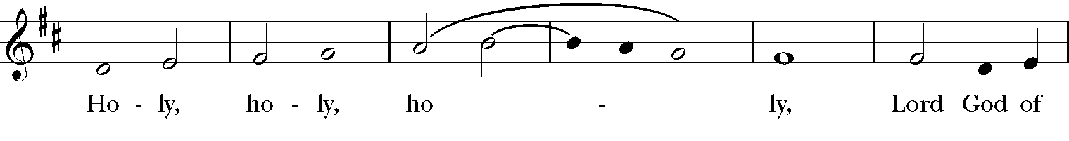
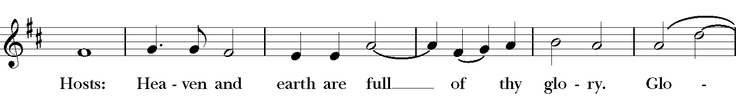
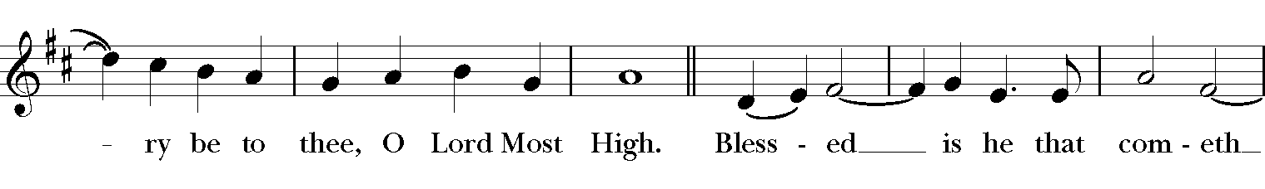
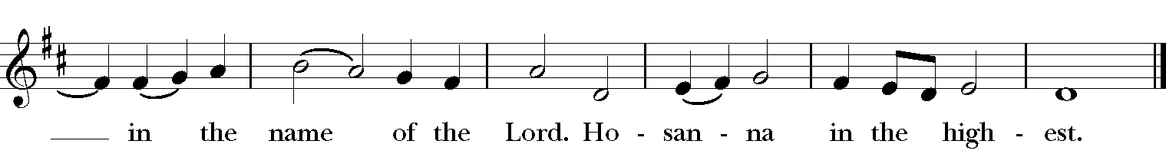

The people kneel or stand.

All glory be to thee, Almighty God, our heavenly Father, for that thou, of thy tender mercy, didst give thine only Son Jesus Christ to suffer death upon the cross for our redemption; who made there, by his one oblation of himself once offered, a full, perfect, and sufficient sacrifice, oblation, and satisfaction, for the sins of the whole world; and did institute, and in his holy Gospel command us to continue, a perpetual memory of that his precious death and sacrifice, until his coming again.
For in the night in which he was betrayed, he took bread; and when he had given thanks, he brake it, and gave it to his disciples, saying, “Take, eat, this is my Body, which is given for you. Do this in remembrance of me.”
Likewise, after supper, he took the cup; and when he had given thanks, he gave it to them, saying, “Drink ye all of this; for this is my Blood of the New Testament, which is shed for you, and for many, for the remission of sins. Do this, as oft as ye shall drink it, in remembrance of me.”
Wherefore, O Lord and heavenly Father, according to the institution of thy dearly beloved Son our Savior Jesus Christ, we, thy humble servants, do celebrate and make here before thy divine Majesty, with these thy holy gifts, which we now offer unto thee, the memorial thy Son hath commanded us to make; having in remembrance his blessed passion and precious death, his mighty resurrection and glorious ascension; rendering unto thee most hearty thanks for the innumerable benefits procured unto us by the same.
And we most humbly beseech thee, O merciful Father, to hear us; and, of thy almighty goodness, vouchsafe to bless and sanctify, with thy Word and Holy Spirit, these thy gifts and creatures of bread and wine; that we, receiving them according to thy Son our Savior Jesus Christ’s holy institution, in remembrance of his death and passion, may be partakers of his most blessed Body and Blood.
And we earnestly desire thy fatherly goodness mercifully to accept this our sacrifice of praise and thanksgiving; most humbly beseeching thee to grant that, by the merits and death of thy Son Jesus Christ, and through faith in his blood, we, and all thy whole Church, may obtain remission of our sins, and all other benefits of his passion.
And here we offer and present unto thee, O Lord, our selves, our souls and bodies, to be a reasonable, holy, and living sacrifice unto thee; humbly beseeching thee that we, and all others who shall be partakers of this Holy Communion, may worthily receive the most precious Body and Blood of thy Son Jesus Christ, be filled with thy grace and heavenly benediction, and made one body with him, that he may dwell in us, and we in him.
And although we are unworthy, through our manifold sins, to offer unto thee any sacrifice, yet we beseech thee to accept this our bounden duty and service, not weighing our merits, but pardoning our offenses, through Jesus Christ our Lord;
By whom, and with whom, in the unity of the Holy Ghost, all honor and glory be unto thee, O Father Almighty, world without end. AMEN.
And now, as our Savior Christ hath taught us, we are bold to say,
People and Celebrant
Our Father who art in heaven,
hallowed be thy Name,
thy kingdom come,
thy will be done,
on earth as it is in heaven.
Give us this day our daily bread.
And forgive us our trespasses
as we forgive those
who trespass against us.
And lead us not into temptation,
but deliver us from evil.
For thine is the kingdom,
and the power, and the glory,
for ever and ever. Amen.
The Breaking of the Bread BCP 327
A period of silence is kept.

Celebrant Christ our Passover is sacrificed for us;
People Therefore let us keep the feast.

Fraction Anthem S158, O Lamb of God (H. Willan)
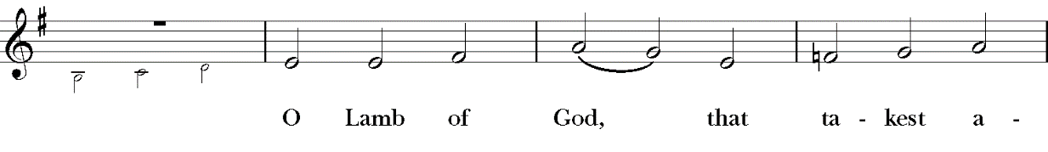
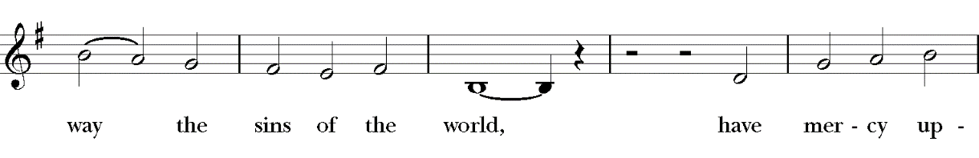
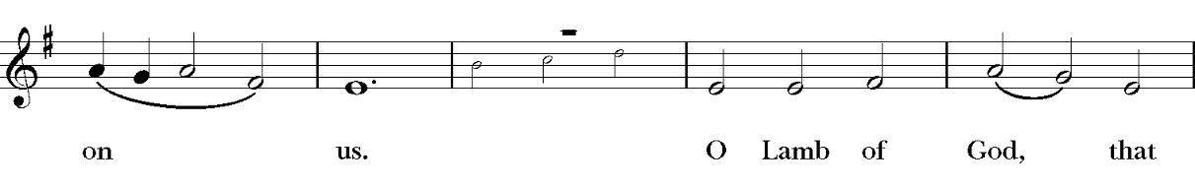
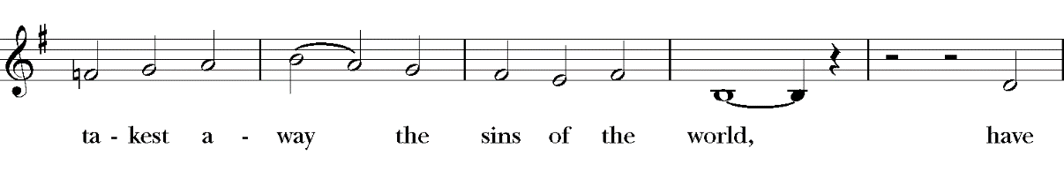
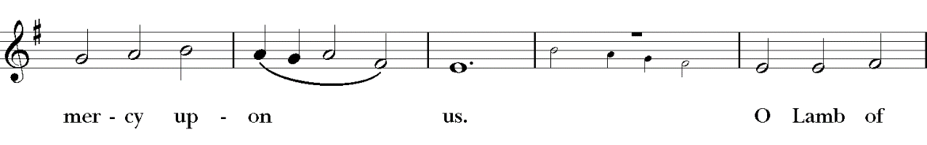
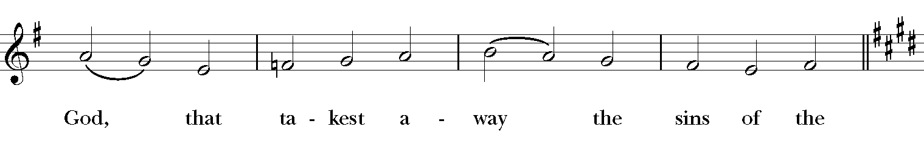
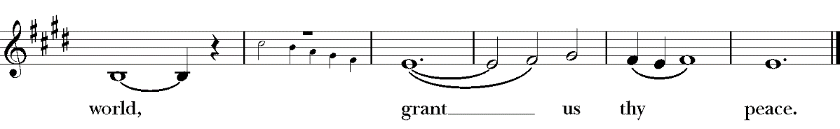
The People may join in saying this prayer
We do not presume to come to this thy Table, O merciful Lord, trusting in our own righteousness, but in thy manifold and great mercies. We are not worthy so much as to gather up the crumbs under thy Table. But thou art the same Lord whose property is always to have mercy. Grant us therefore, gracious Lord, so to eat the flesh of thy dear Son Jesus Christ, and to drink his blood, that we may evermore dwell in him, and he in us. Amen.

Celebrant
The Gifts of God for the People of God. Take them in remembrance that Christ died for you, and feed on him in your hearts by faith, with thanksgiving.

Communion Anthem: All who love and serve your city (P. Cutts)

The Post Communion Prayer
After Communion, the Celebrant says
Let us pray.

Celebrant and People
Eternal God, heavenly Father,
you have graciously accepted us as living members
of your Son our Savior Jesus Christ,
and you have fed us with spiritual food
in the Sacrament of his Body and Blood.
Send us now into the world in peace,
and grant us strength and courage
to love and serve you
with gladness and singleness of heart;
through Christ our Lord. Amen.

The Blessing
The priest blesses the people, saying
The peace of God which passes all understanding keep your hearts and minds in the love of God and of Jesus Christ our Lord, his son. And, the blessing of God, Almighty Father, Son, and Holy Spirit be upon you this day and remain with you always. Amen.

Hymn 71 Hark the glad sound! The Savior comes (Richmond) 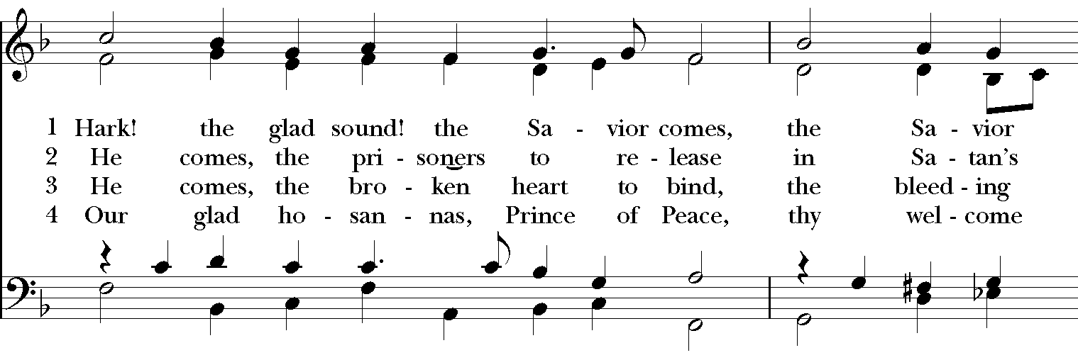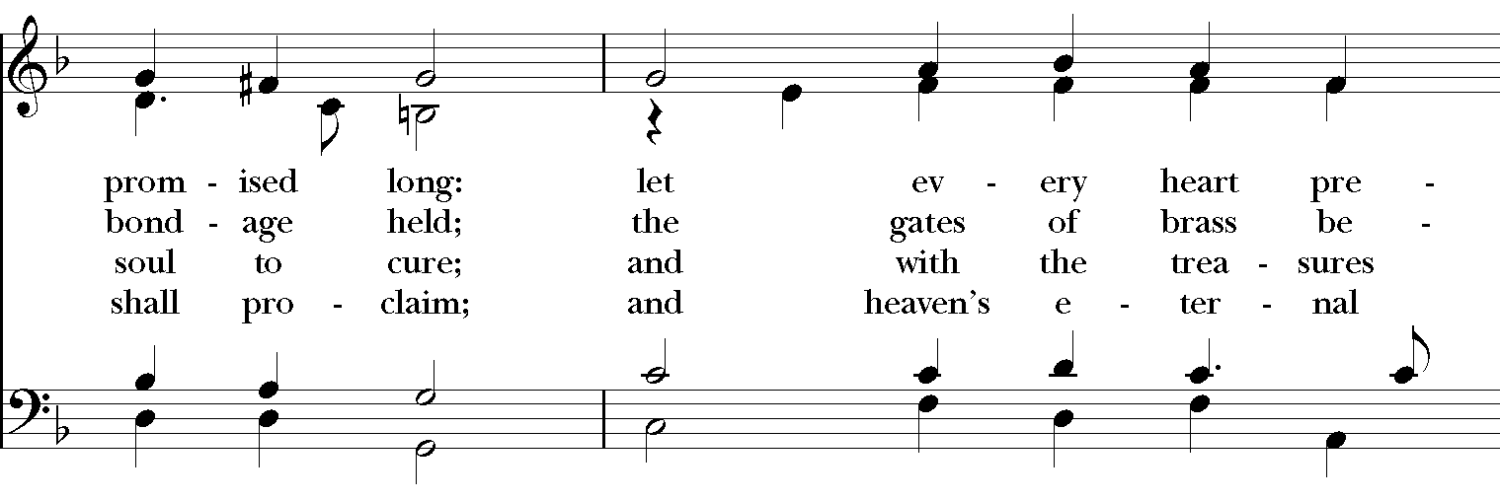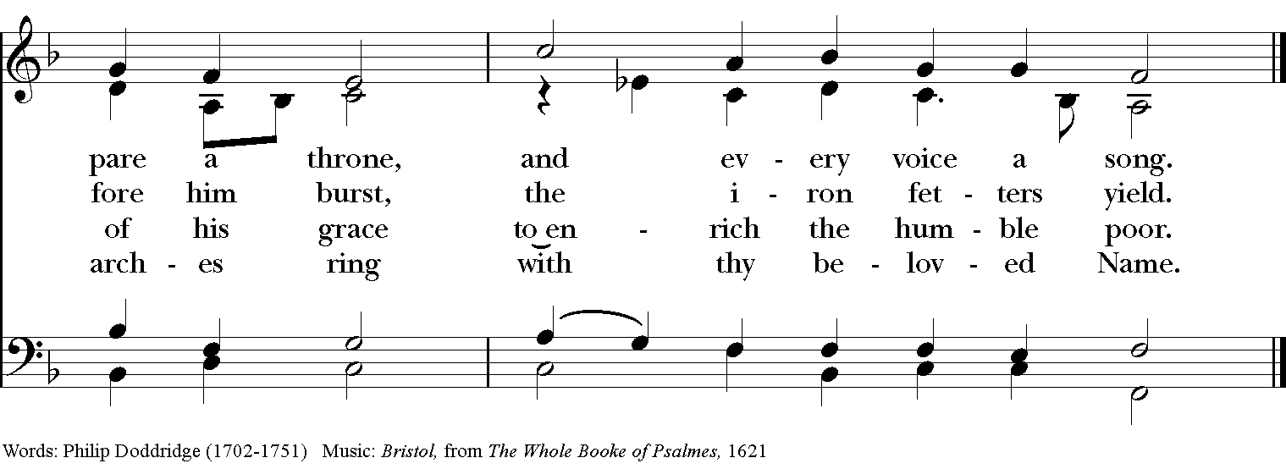

Dismissal
Celebrant Go in peace to love and serve the Lord. Alleluia. Alleluia.
People Thanks be to God. Alleluia. Alleluia.

Altar Flowers
Today’s altar flowers are given in honor of
The Baptism of Charles Nelson Gill Jr.
And In Memory of His Great Uncles
Dr. Charles Leigh Gill and Dr. Gordon Nelson Gill

Prayers for Ascension
Parishioners: Clyde Eller, Glenn Cain, Nancy Morgan, Robin Starke, Ellen Brooks, Diane Williams, Sam Knight, Richard Norris, Bill Wall, Jimmy Yoder, Ann Thorington, Chris Lewis, Al Cantrell, Sue Hicks, Violet Monson, Frances Hill, Jane McConnell, Betty Godbold, Sophie Xides, Edith Crook

Families and Friends: Billy Harper, Sandra Mcinnes, Ramsey Ashmore, Cerina and Jon Crooks, Jules Hobbie, Wayna Prater, Jacqueline Floyd, Laura Kate Ryan, JoAnn Boozer Ray
Text-to-Give is now available. Text the word “give” to 833-901-2138. To give from our website simply click the green “GIVE HERE” button. You can also contact Tracy Hinton, our Parish Administrator, at thinton@coascension.org or at 334-263-5520 to set up a bank draft. Or you can mail your contribution to us at Church of the Ascension; c/o Tracy Hinton; 315 Clanton Ave; Montgomery, AL 36104.

Adult Formation Online

Bread of Life † Library
Crazy Christians by Michael Curry
August 15 - December 12
In-Person and on Zoom
We need some Christians who are as crazy as the Lord. Crazy enough to love like Jesus, to give like Jesus, to forgive like Jesus, to do justice, love mercy, walk humbly with God―like Jesus. Crazy enough to dare to change the world from the nightmare it often is into something close to the dream that God dreams for it. And for those who would follow him, those who would be his disciples, those who would live as and be the people of the Way? It might come as a shock, but they are called to craziness. —from Bishop Curry's "Crazy Christians" address to the 2012 General Convention of the Episcopal Church in Indianapolis. Come find out what this craziness is all about!

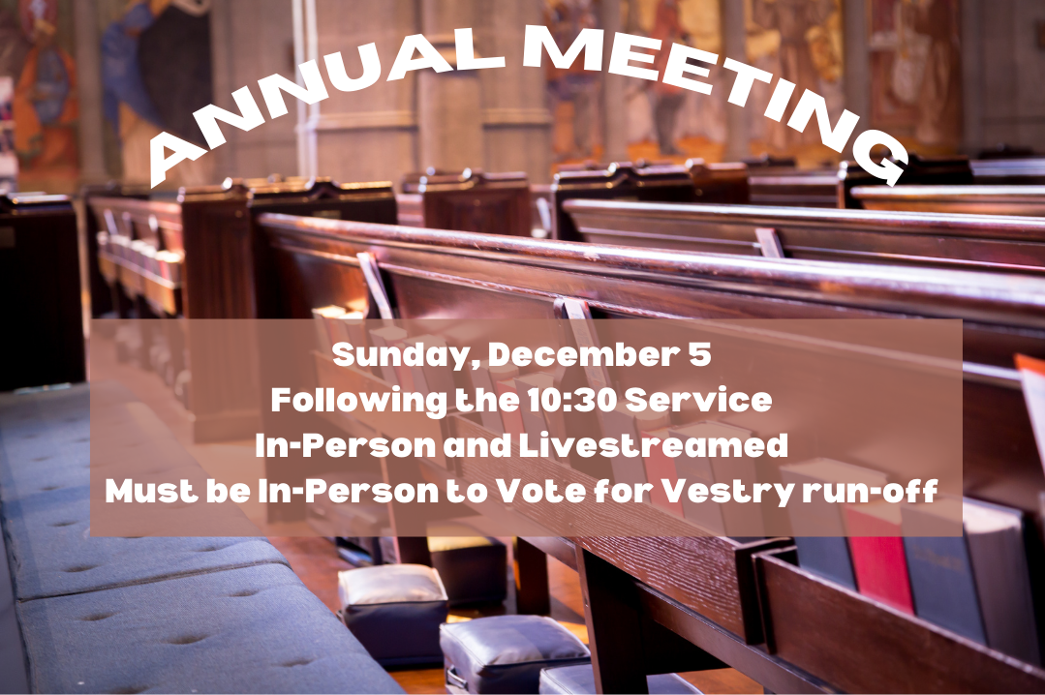

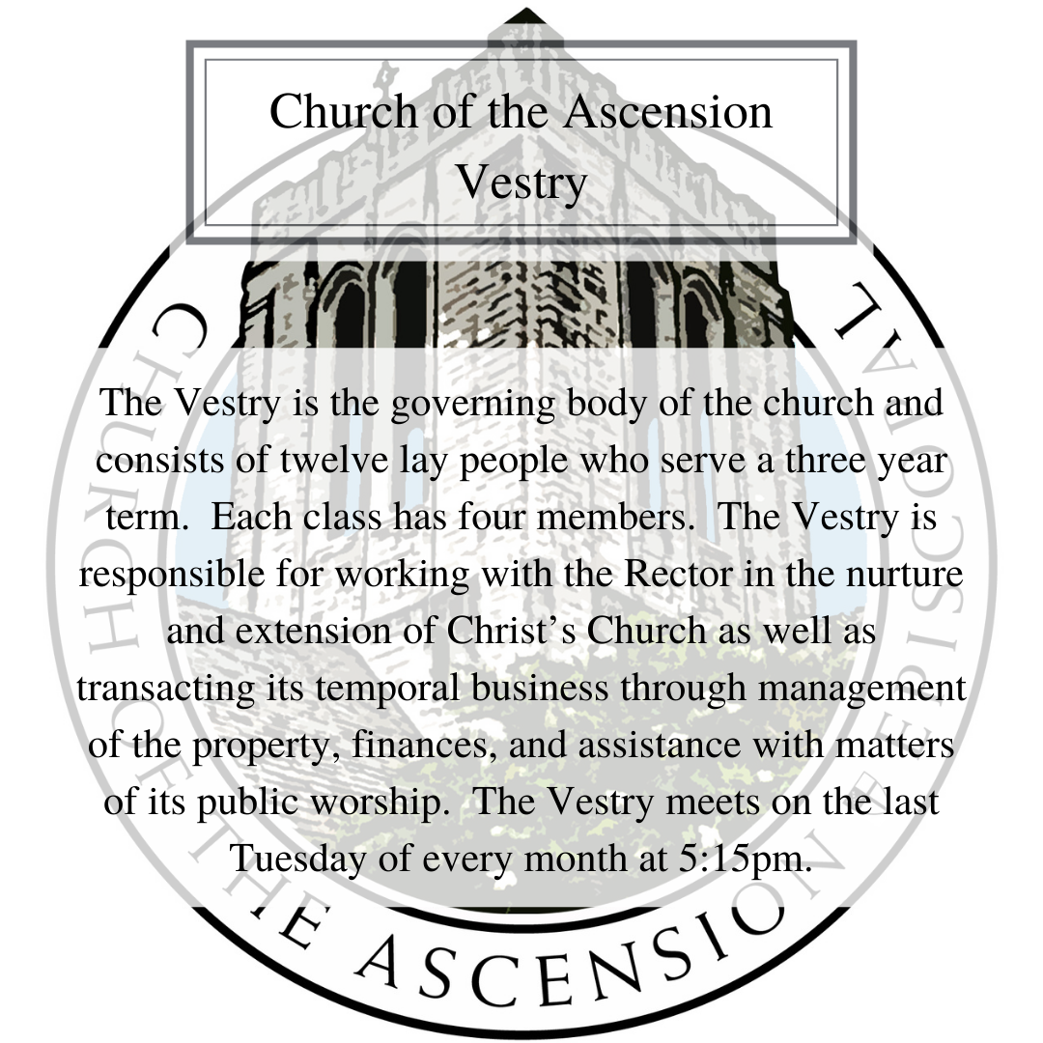
Church of The Ascension
315 Clanton Avenue
Montgomery, AL 36104
(334)263-5529, staff@coascension.org

www.coascension.org

Like and follow us on Facebook, Instagram, YouTube and your favorite Podcast Channel
The Episcopal Church of the Ascension

