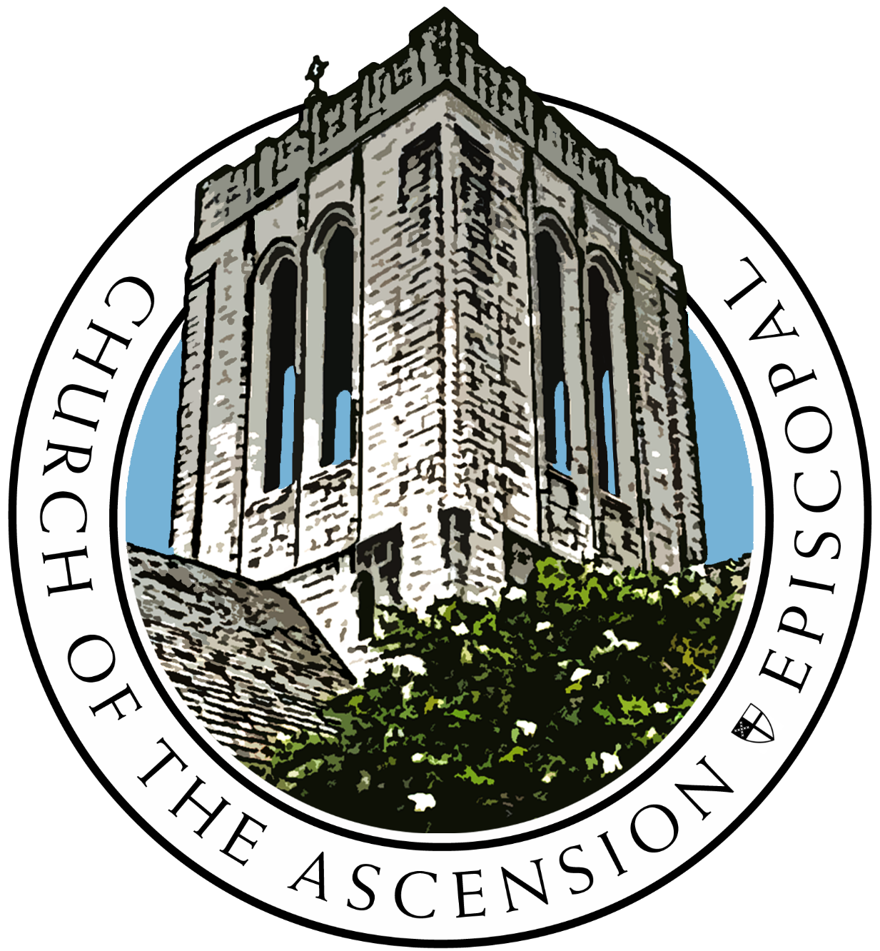

Church of the Ascension
We believe in sharing love and grace by seeking relationship with God and one another.

Fifth Sunday In Easter
Sunday, May 15th, 2022
The Reverend Candice B. Frazer, Rector
The Reverend Andrew S. Brislin, Associate Rector

Organist/ Choirmaster: Rebecca B. Taylor
Lector: Glenn Slyvest
LEMs: Andy Akin
and Nan Barganier

Verger: Susan Copeland
Altar Guild: Debbie Hackett and Margaret Hunt
AV Crew: Riley Harrison, Russel Bush, Sound

Holy Eucharist Rite One 10:30 AM Livestream

Voluntary Partita on “Laudate Dominum” (C. Callahan)
Introit Lord, whose love through humble service (A. F. Bayly)

Hymn 432 O praise ye the Lord! Praise him in the height (Laudate Dominum) 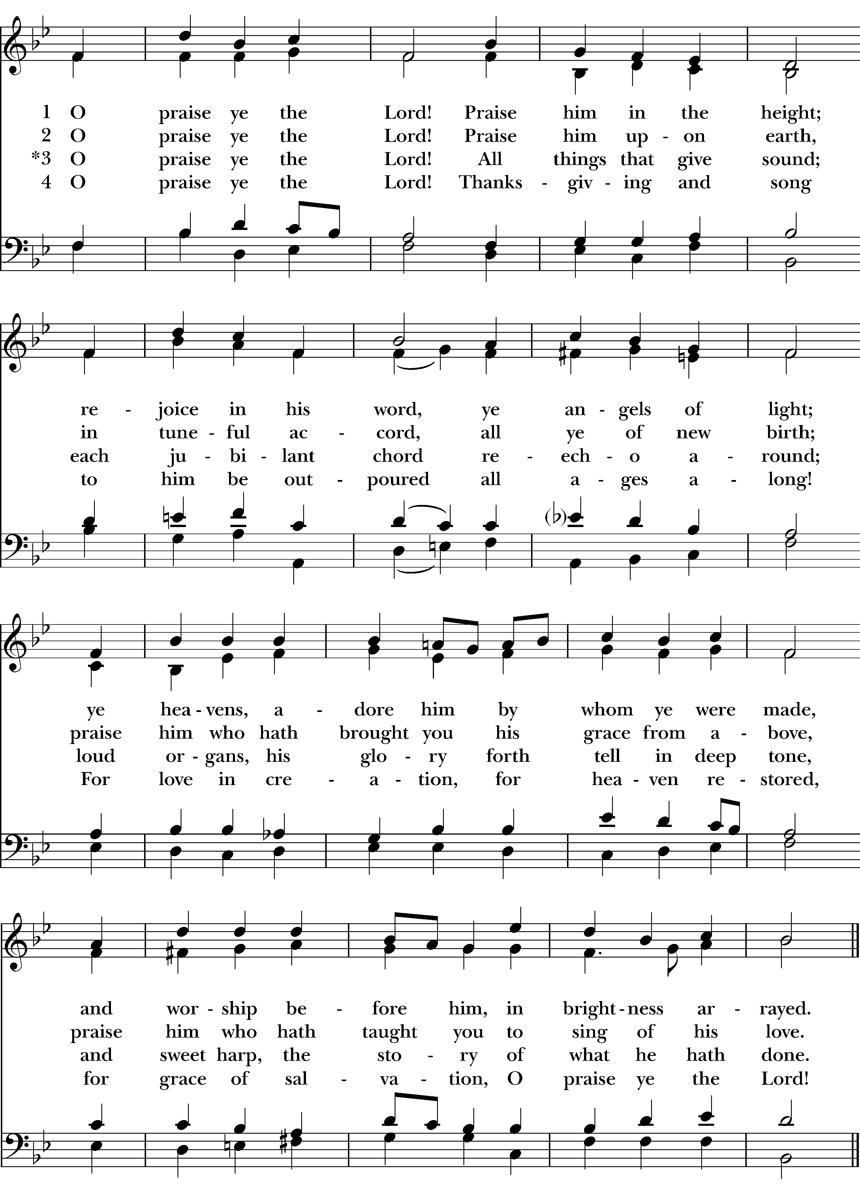

The Word of God
Celebrant: Alleluia, Christ is risen.
People: The Lord is risen indeed. Alleluia.

The Celebrant then continues

There is one Body and one Spirit;
People There is one hope in God's call to us;
Celebrant One Lord, one Faith, one Baptism;
People One God and Father of all.

Celebrant The Lord be with you.
People And also with you.
Celebrant Let us pray.

Collect of the Day BCP 355
Celebrant The Lord be with you.
People And also with you.
Celebrant Let us pray.
Almighty God, whom truly to know is everlasting life: Grant us so perfectly to know your Son Jesus Christ to be the way, the truth, and the life, that we may steadfastly follow his steps in the way that leads to eternal life; through Jesus Christ your Son our Lord, who lives and reigns with you, in the unity of the Holy Spirit, one God, for ever and ever. Amen.

First Reading Acts 11:1-18
A Reading from the Book of Acts.

Now the apostles and the believers who were in Judea heard that the Gentiles had also accepted the word of God. So when Peter went up to Jerusalem, the circumcised believers criticized him, saying, "Why did you go to uncircumcised men and eat with them?" Then Peter began to explain it to them, step by step, saying, "I was in the city of Joppa praying, and in a trance I saw a vision. There was something like a large sheet coming down from heaven, being lowered by its four corners; and it came close to me. As I looked at it closely I saw four-footed animals, beasts of prey, reptiles, and birds of the air. I also heard a voice saying to me, `Get up, Peter; kill and eat.' But I replied, `By no means, Lord; for nothing profane or unclean has ever entered my mouth.' But a second time the voice answered from heaven, `What God has made clean, you must not call profane.' This happened three times; then everything was pulled up again to heaven. At that very moment three men, sent to me from Caesarea, arrived at the house where we were. The Spirit told me to go with them and not to make a distinction between them and us. These six brothers also accompanied me, and we entered the man's house. He told us how he had seen the angel standing in his house and saying, `Send to Joppa and bring Simon, who is called Peter; he will give you a message by which you and your entire household will be saved.' And as I began to speak, the Holy Spirit fell upon them just as it had upon us at the beginning. And I remembered the word of the Lord, how he had said, `John baptized with water, but you will be baptized with the Holy Spirit.' If then God gave them the same gift that he gave us when we believed in the Lord Jesus Christ, who was I that I could hinder God?" When they heard this, they were silenced. And they praised God, saying, "Then God has given even to the Gentiles the repentance that leads to life."
Reader The Word of the Lord.
People Thanks be to God.

Psalm 148 Laudate Dominum

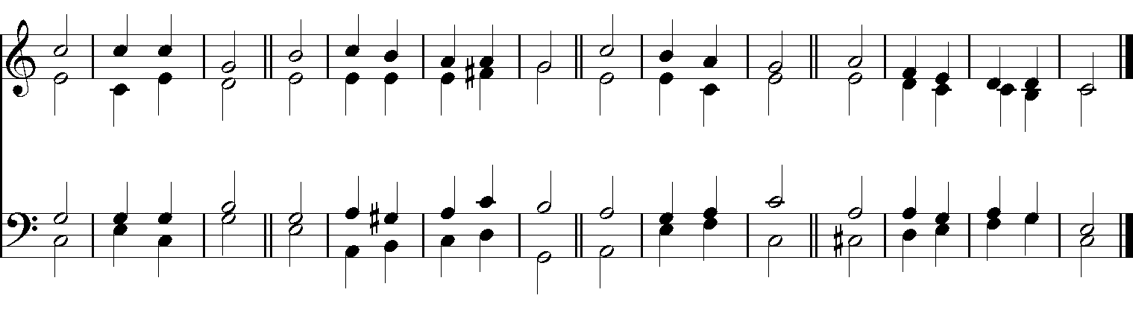

A B

1 Hallelujah!
Praise the Lord / from the / heavens; *
--- / praise him / in the / heights.
2 Praise him, all you / angels • of / his; *
praise / him, / all his / host.

3 Praise him, / sun and / moon; *
praise him, / all you / shin - ing / stars.
4 Praise him, / heaven • of / heavens, *
and you / waters • a- / bove the / heavens.

5 Let them praise the / Name of • the / Lord; *
for he com- / manded, • and / they were . cre- / ated.
6 He made them stand fast for / ever • and / ever; *
he gave them a law which / shall not / pass a- / way.

7 Praise the Lord / from the / earth, *
you / sea-monsters • and / all / deeps;
8 Fire and hail, / snow and / fog, *
tempestuous / wind, / doing • his / will;

9 Mountains / and all / hills, *
--- /fruit trees • and / all / cedars;
10 Wild beasts / and all / cattle, *
creeping / things and / winged / birds;

11 Kings of the earth / and all / peoples, *
princes and all / ru - lers / of the / world;
12 Young / men and / maidens, *
--- / old and / young to- / gether.

13 Let them praise the / Name of • the / Lord, *
for his Name only is exalted,
his splendor is / o - ver / earth and / heaven.
14 He has raised up strength for his people
and praise for all his / loy - al / servants, *
the children of Israel, a people who are / near him. /
Hal - -le- / lujah!

Second Reading Revelations 21:1-6
A reading from the Book of Revelations.

I saw a new heaven and a new earth; for the first heaven and the first earth had passed away, and the sea was no more. And I saw the holy city, the new Jerusalem, coming down out of heaven from God, prepared as a bride adorned for her husband. And I heard a loud voice from the throne saying,

"See, the home of God is among mortals.
He will dwell with them as their God;
they will be his peoples,
and God himself will be with them;
he will wipe every tear from their eyes.
Death will be no more;
mourning and crying and pain will be no more,
for the first things have passed away."

And the one who was seated on the throne said, "See, I am making all things new." Also he said, "Write this, for these words are trustworthy and true." Then he said to me, "It is done! I am the Alpha and the Omega, the beginning and the end. To the thirsty I will give water as a gift from the spring of the water of life."

Reader The Word of the Lord.
People Thanks be to God.

Hymn 487 Come, my Way, my Truth, my Life (The Call)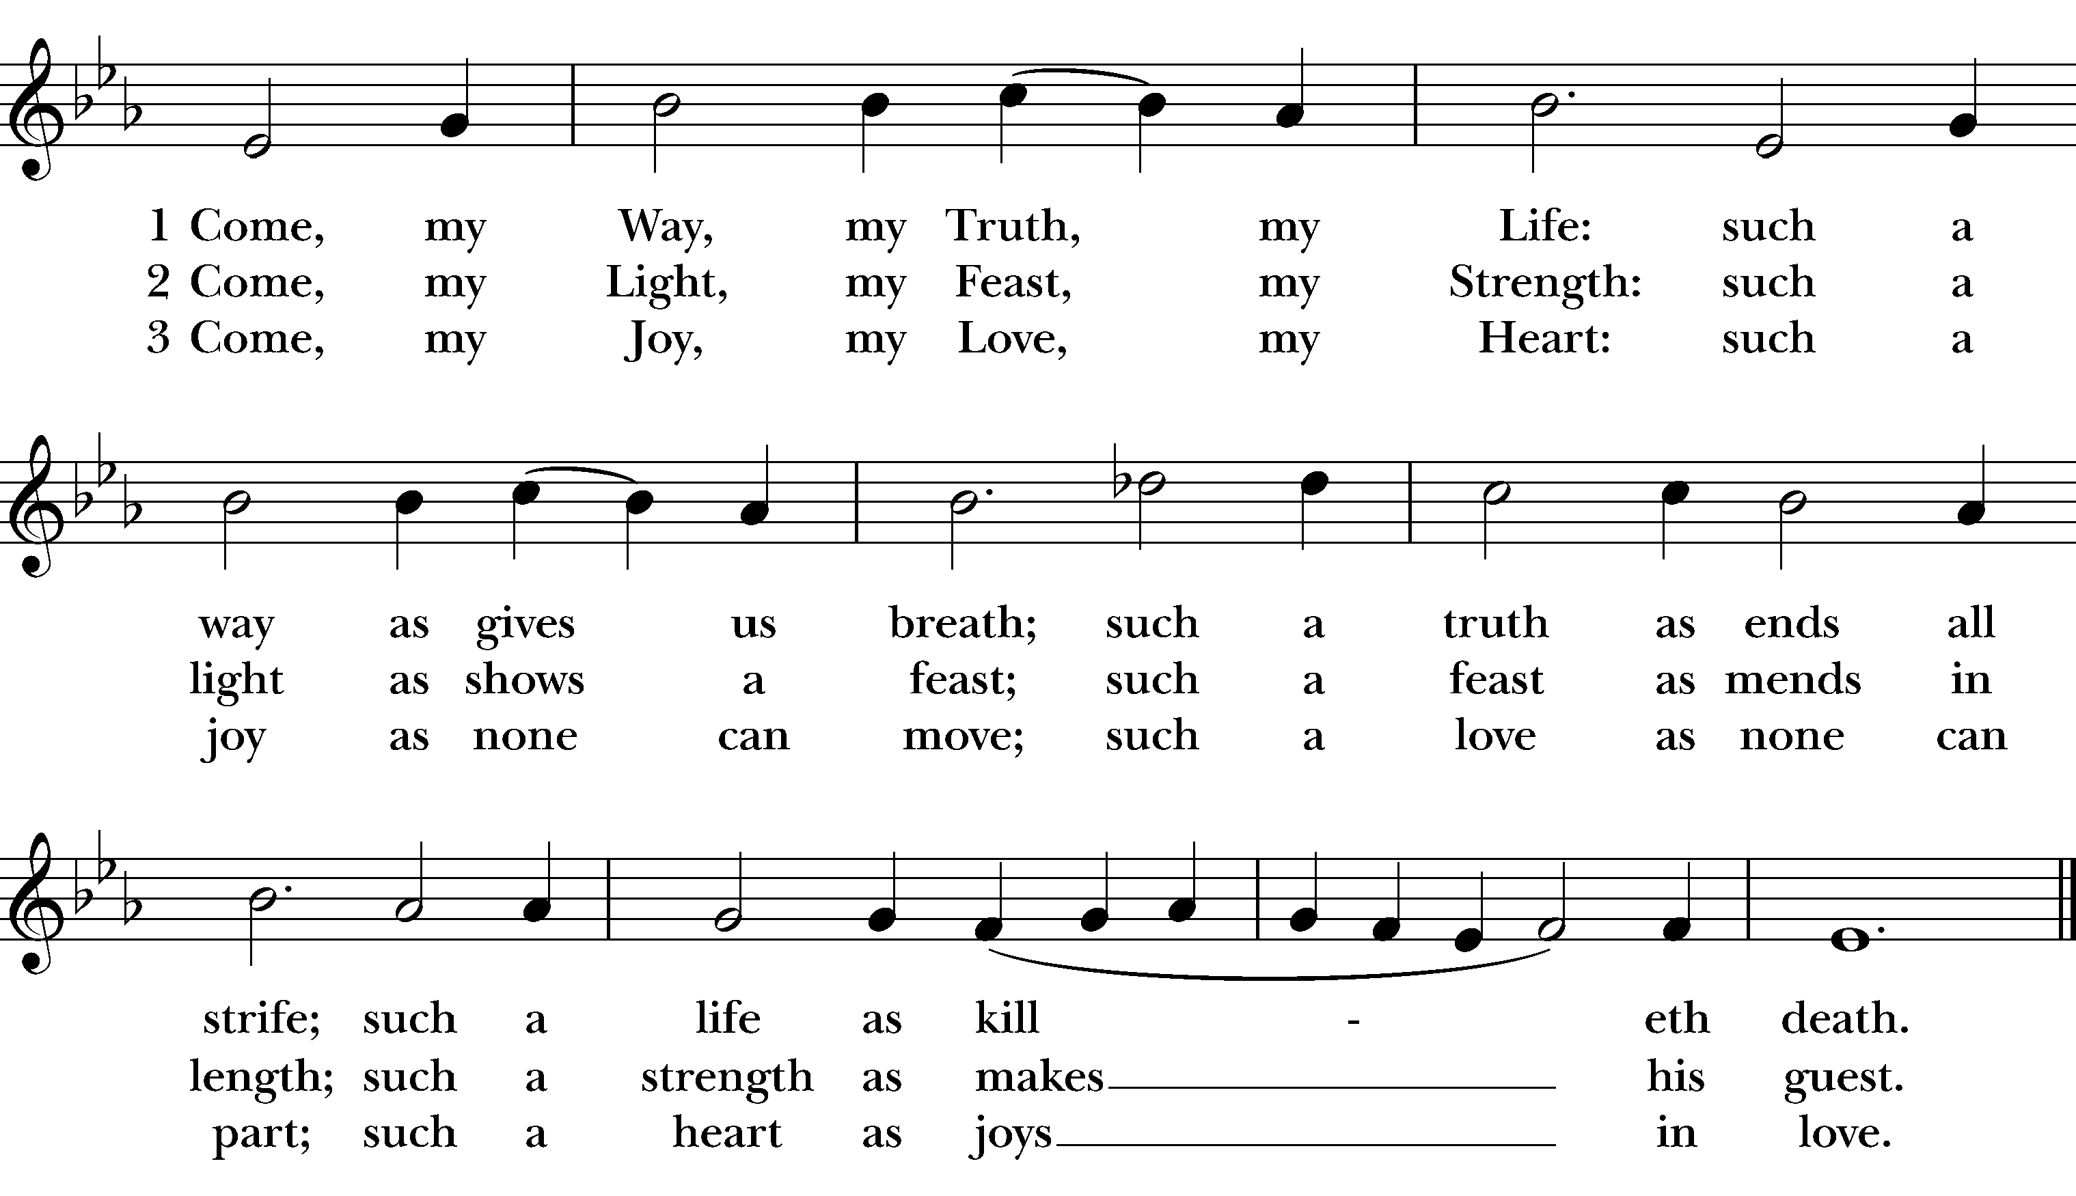

Holy Gospel John 13:31-35
Celebrant The Holy Gospel of our Lord Jesus Christ according to John.
People Glory to you, Lord Christ.

At the last supper, when Judas had gone out, Jesus said, "Now the Son of Man has been glorified, and God has been glorified in him. If God has been glorified in him, God will also glorify him in himself and will glorify him at once. Little children, I am with you only a little longer. You will look for me; and as I said to the Jews so now I say to you, 'Where I am going, you cannot come.' I give you a new commandment, that you love one another. Just as I have loved you, you also should love one another. By this everyone will know that you are my disciples, if you have love for one another."

Celebrant The Gospel of the Lord.
People Praise to you, Lord Christ.

Sermon The Rev. Candice B. Frazer

Presentation and Examination of Candidates BCP 301
The Celebrant says
The Candidate(s) for Holy Baptism will now be presented.

Parents and Godparents
I present Miles to receive the Sacrament of Baptism.

When all have been presented the Celebrant asks the parents and godparents
Will you be responsible for seeing that the child you present is brought up in the Christian faith and life?

Parents and Godparents
I will, with God’s help.

Celebrant
Will you by your prayers and witness help this child to grow into the full stature of Christ?

Parents and Godparents
I will, with God’s help.

Then the Celebrant asks the following questions of the candidates who can speak for themselves, and of the parents and godparents who speak on behalf of the infants and younger children

Question | Do you renounce Satan and all the spiritual forces of wickedness that rebel against God?
Answer | I renounce them.
Question | Do you renounce the evil powers of this world which corrupt and destroy the creatures of God?
Answer | I renounce them.
Question | Do you renounce all sinful desires that draw you from the love of God?
Answer | I renounce them.
Question | Do you turn to Jesus Christ and accept him as your Savior?
Answer | I do.
Question | Do you put your whole trust in his grace and love?
Answer | I do.
Question | Do you promise to follow and obey him as your Lord?
Answer | I do.

Celebrant addresses the congregation, saying
Will you who witness these vows do all in your power to support these persons in their life in Christ?

People We will.

The Celebrant then says these or similar words
Let us join with those who are committing themselves to Christ and renew our own baptismal covenant.

The Baptismal Covenant BCP 304
Celebrant | Do you believe in God the Father?
People | I believe in God, the Father almighty,  creator of heaven and earth.
Celebrant | Do you believe in Jesus Christ, the Son of God?
People | I believe in Jesus Christ, his only Son, our Lord.  He was conceived by the power of the Holy Spirit  and born of the Virgin Mary.  He suffered under Pontius Pilate,  was crucified, died, and was buried.  He descended to the dead.  On the third day he rose again.  He ascended into heaven,  and is seated at the right hand of the Father.  He will come again to judge the living and the dead.
Celebrant | Do you believe in God the Holy Spirit?
People | I believe in the Holy Spirit,  the holy catholic Church,  the communion of saints,  the forgiveness of sins,  the resurrection of the body,  and the life everlasting.
Celebrant | Will you continue in the apostles’ teaching and fellowship, in the breaking of bread, and in the prayers?
People | I will, with God’s help.
Celebrant | Will you persevere in resisting evil, and, whenever you fall into sin, repent and return to the Lord?
People | I will, with God’s help.
Celebrant | Will you proclaim by word and example the Good News of God in Christ?
People | I will, with God’s help.
Celebrant | Will you seek and serve Christ in all persons, loving your neighbor as yourself?
People | I will, with God’s help.
Celebrant | Will you strive for justice and peace among all people, and respect the dignity of every human being?
People | I will, with God’s help.

Prayers for the Candidates BCP 305
The Celebrant then says to the congregation
Let us now pray for this person who is to receive the Sacrament of new birth.
A Person appointed leads the following petitions
Leader | Deliver Miles, O Lord, from the way of sin and death.
People | Lord, hear our prayer.
Leader | Open his heart to your grace and truth.
People | Lord, hear our prayer.
Leader | Fill him with your holy and life-giving Spirit.
People | Lord, hear our prayer.
Leader | Keep him in the faith and communion of your holy Church.
People | Lord, hear our prayer.
Leader | Teach him to love others in the power of the Spirit.
People | Lord, hear our prayer.
Leader | Send him into the world in witness to your love.
People | Lord, hear our prayer.
Leader | Bring him to the fullness of your peace and glory.
People | Lord, hear our prayer.

The Celebrant says
Grant, O Lord, that all who are baptized into the death of Jesus Christ your Son may live in the power of his resurrection and look for him to come again in glory; who lives and reigns now and for ever. Amen.

Thanksgiving Over the Water BCP 306
The Celebrant blesses the water, first saying
 | The Lord be with you.
People | And also with you.
Celebrant | Let us give thanks to the Lord our God.
People | It is right to give him thanks and praise.

Celebrant
We thank you, Almighty God, for the gift of water. Over it the Holy Spirit moved in the beginning of creation. Through it you led the children of Israel out of their bondage in Egypt into the land of promise. In it your Son Jesus received the baptism of John and was anointed by the Holy Spirit as the Messiah, the Christ, to lead us, through his death and resurrection, from the bondage of sin into everlasting life.

We thank you, Father, for the water of Baptism. In it we are buried with Christ in his death. By it we share in his resurrection. Through it we are reborn by the Holy Spirit. Therefore in joyful obedience to your Son, we bring into his fellowship those who come to him in faith, baptizing them in the Name of the Father, and of the Son, and of the Holy Spirit.

At the following words, the Celebrant touches the water
Now sanctify this water, we pray you, by the power of your Holy Spirit, that those who here are cleansed from sin and born again may continue for ever in the risen life of Jesus Christ our Savior.

To him, to you, and to the Holy Spirit, be all honor and glory, now and for ever. Amen.

The Baptism BCP 307
The candidate is presented to the Celebrant, who then immerses, or pours water upon, the candidate, saying
Miles, I baptize you in the Name of the Father, and of the Son, and of the Holy Spirit. Amen.

When this action has been completed, the Priest, at a place in full sight of the congregation, prays over them, saying

Let us pray.
Heavenly Father, we thank you that by water and the Holy Spirit you have bestowed upon this your servant the forgiveness of sin, and have raised him to the new life of grace. Sustain him, O Lord, in your Holy Spirit. Give him an inquiring and discerning heart, the courage to will and to persevere, a spirit to know and to love you, and the gift of joy and wonder in all your works. Amen.

Then the Bishop or Priest places a hand on the person’s head, marking on the forehead the sign of the cross [using Chrism if desired] and saying to each one

Miles, you are sealed by the Holy Spirit in Baptism and marked as Christ’s own for ever. Amen.

Let us welcome the newly baptized.

Celebrant and People
We receive you into the household of God. Confess the faith of Christ crucified, proclaim his resurrection, and share with us in his eternal priesthood.

Celebrant | The peace of the Lord be always with you.
People | And also with you.

And now as our Savior BCP 311
Christ has taught us,
we are bold to say,

Our Father who art in heaven,
hallowed be thy Name,
thy kingdom come,
thy will be done,
on earth as it is in heaven.
Give us this day our daily bread.
And forgive us our trespasses
as we forgive those
who trespass against us.
And lead us not into temptation,
but deliver us from evil.
For thine is the kingdom,
and the power, and the glory,
for ever and ever. Amen.

The Celebrant then says
All praise and thanks to you, most merciful Father, for adopting us as your own children, for incorporating us into your holy Church, and for making us worthy to share in the inheritance of the saints in light; through Jesus Christ your Son our Lord, who lives and reigns with you and the Holy Spirit, one God, for ever and ever. Amen.

Almighty God, the Father of our Lord Jesus Christ, from whom every family in heaven and earth is named, grant you to be strengthened with might by his Holy Spirit, that, Christ dwelling in your hearts by faith, you may be filled with all the fullness of God. Amen.

The Peace
Celebrant The peace of the Lord be always with you.
People And with thy spirit.

Announcements
Giving is available on-line by going to www.coascension.org and click on the “Give” link
Or, text the word “GIVE” to (833)901-2138 and follow as prompted.
Or, VENMO @churchoftheascension (look for our logo in color or gold

Offertory Anthem Love divine, all loves excelling (M. Wilberg)

Presentation
All things come of thee, O Lord,
And of thine own have we given thee. Amen.

Holy Communion
Great Thanksgiving, Eucharistic Prayer B
Celebrant The Lord be with you.
People And also with you.
Celebrant Lift up your hearts.
People We lift them to the Lord.
Celebrant Let us give thanks to the Lord our God.
People It is right to give God thanks and praise.

The Celebrant proceeds
It is right, and a good and joyful thing, always and every where to give thanks to you, Father Almighty, Creator of heaven and earth.

But chiefly are we bound to praise you for the glorious resurrection of your Son Jesus Christ our Lord; for he is the true Paschal Lamb, who was sacrificed for us, and has taken away the sin of the world. By his death he has destroyed death, and by his rising to life again he has won for us everlasting life.

Therefore we praise you, joining our voices with Angels and Archangels and with all the company of heaven, who for ever sing this hymn to proclaim the glory of your Name:

Sanctus Hymn S128 Holy, holy, holy Lord (W. Mathias) 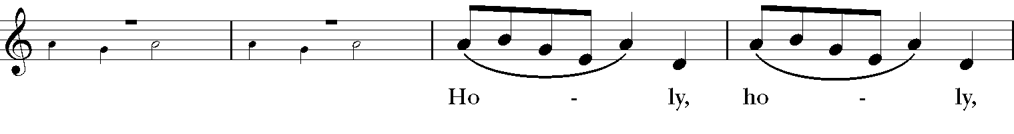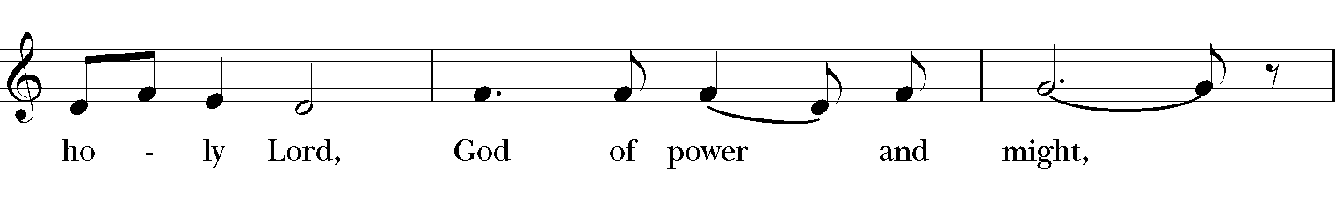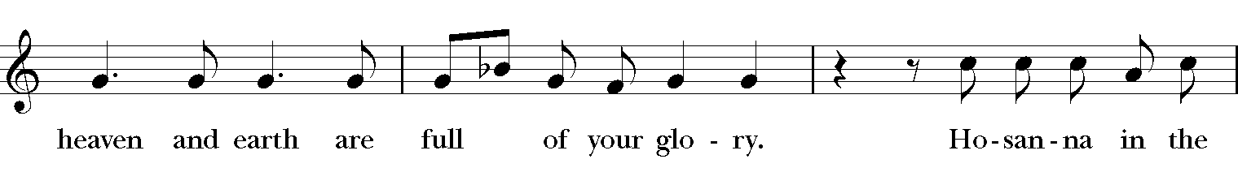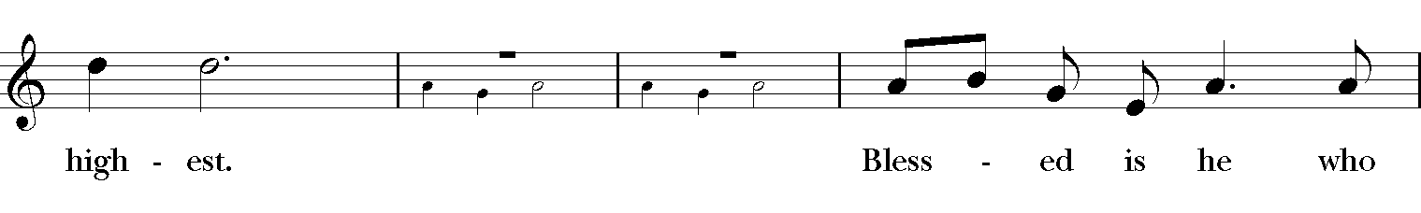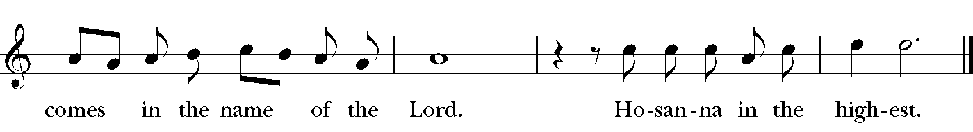

Then the Celebrant continues
We give thanks to you, O God, for the goodness and love which you have made known to us in creation; in the calling of Israel to be your people; in your Word spoken through the prophets; and above all in the Word made flesh, Jesus, your Son. For in these last days you sent him to be incarnate from the Virgin Mary, to be the Savior and Redeemer of the world. In him, you have delivered us from evil, and made us worthy to stand before you. In him, you have brought us out of error into truth, out of sin into righteousness, out of death into life.

On the night before he died for us, our Lord Jesus Christ took bread; and when he had given thanks to you, he broke it, and gave it to his disciples, and said, “Take, eat: This is my Body, which is given for you. Do this for the remembrance of me.”

After supper he took the cup of wine; and when he had given thanks, he gave it to them, and said, “Drink this, all of you: This is my Blood of the new Covenant, which is shed for you and for many for the forgiveness of sins. Whenever you drink it, do this for the remembrance of me.”
Therefore, according to his command, O Father,

Celebrant and People

Memorial Acclamation Hymn S138 We remember his death (M. Robinson)
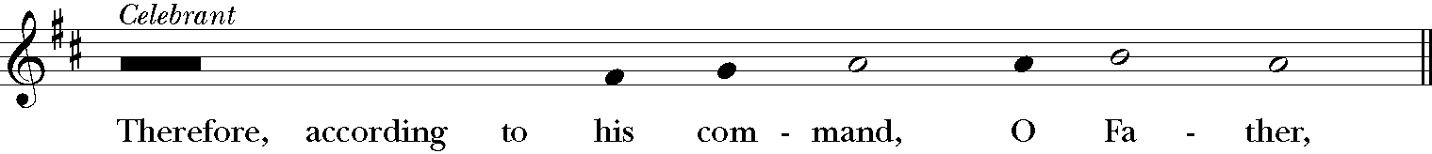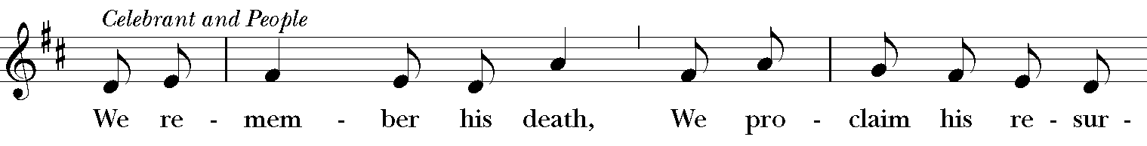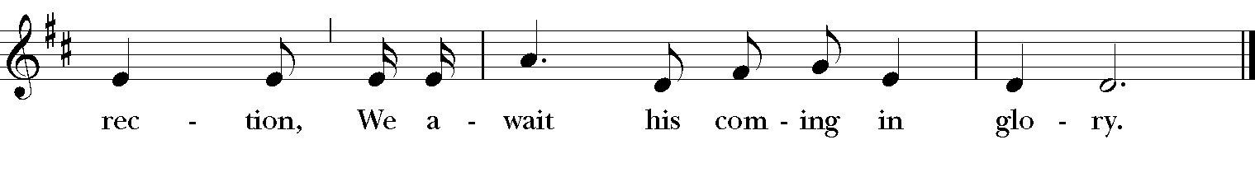
And we offer our sacrifice of praise and thanksgiving to you, O Lord of all; presenting to you, from your creation, this bread and this wine.

We pray you, gracious God, to send your Holy Spirit upon these gifts that they may be the Sacrament of the Body of Christ and his Blood of the new Covenant. Unite us to your Son in his sacrifice, that we may be acceptable through him, being sanctified by the Holy Spirit. In the fullness of time, put all things in subjection under your Christ, and bring us to that heavenly country where, with all your saints, we may enter the everlasting heritage of your children; through Jesus Christ our Lord, the firstborn of all creation, the head of the Church, and the author of our salvation.

By him, and with him, and in him, in the unity of the Holy Spirit all honor and glory is yours, Almighty Father, now and for ever. Amen.

And now, as our Savior
Christ has taught us,
We are bold to say

Officiant and People BCP 364
Our Father who art in heaven,
hallowed be thy Name,
thy kingdom come,
thy will be done,
on earth as it is in heaven.
Give us this day our daily bread.
And forgive us our trespasses
as we forgive those
who trespass against us.
And lead us not into temptation,
but deliver us from evil.
For thine is the kingdom,
and the power, and the glory,
for ever and ever. Amen.

Breaking of the Bread BCP 364
A period of silence is kept.

Alleluia. Christ our Passover is sacrificed for us;
Therefore let us keep the feast. Alleluia.

Fraction Anthem Hymn S165 Jesus, Lamb of God (W. Mathias)
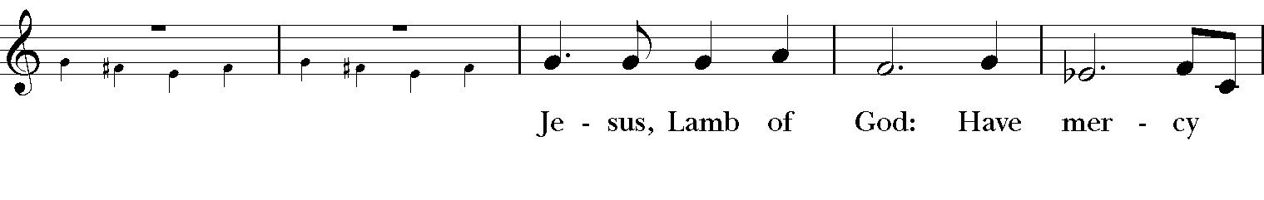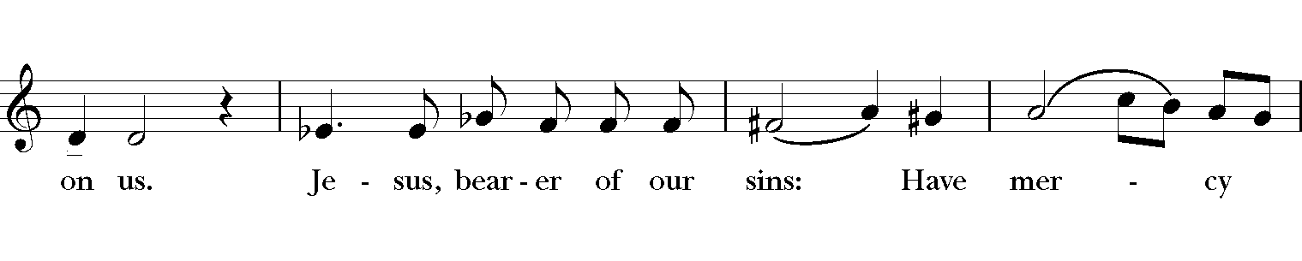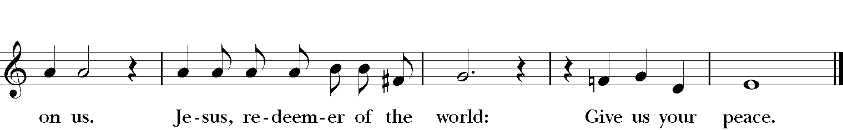

The Celebrant says
The Gifts of God for the People of God. Take them in remembrance that Christ died for you, and feed on him in your hearts by faith with thanksgiving.

Communion Anthem Let us love one another (A. Bullock)
Communion Hymn: 576 and 606

Lay Eucharistic Commission

In the name of this congregation, we send you forth bearing these holy gifts, that those to whom you go may share with us in the communion of Christ’s body and blood.

All: We who are many, are one body because we all share in one bread, one cup.

Post Communion Prayer
After Communion, the Celebrant says
Let us pray.

The People may join in saying this prayer
Almighty and everliving God, we thank you for feeding us with the spiritual food of the most precious Body and Blood of your Son our Savior Jesus Christ; and for assuring us in these holy mysteries that we are living members of the Body of your Son, and heirs of your eternal kingdom. And now, Father, send us out to do the work you have given us to do, to love and serve you as faithful witnesses of Christ our Lord. To him, to you, and to the Holy Spirit, be honor and glory, now and for ever. Amen.

Blessing
The priest blesses the people, saying
The God of peace, who brought again from the dead our Lord Jesus Christ, the great Shepherd of the sheep, through the blood of the everlasting covenant, make you perfect tn every good work to do his will, working in you that which is well-pleasing in his sight; and the blessing of God Almighty the Father, the Son, and the Holy Spirit, be upon you and remain with you forever. Amen.

Hymn in Procession 603 When Christ was lifted from the earth (St. Botolph)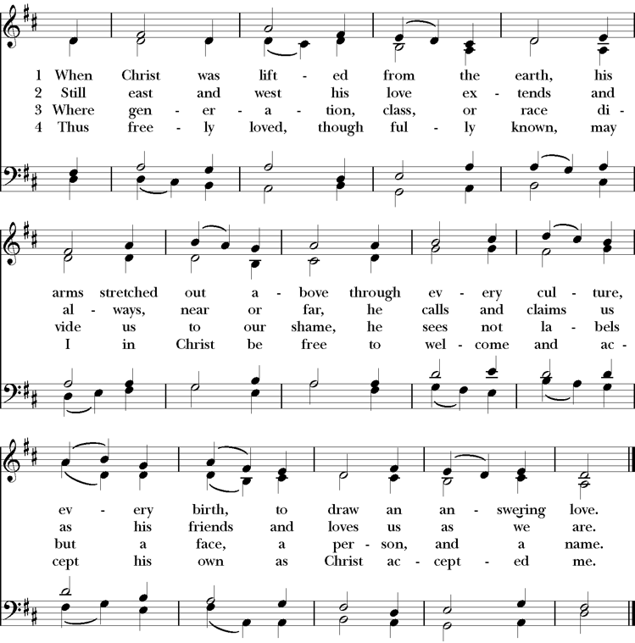

Dismissal
Let us go forth in the name of the Risen Lord. Alleluia, Alleluia!
Thanks be to God. Alleluia, Alleluia!

Voluntary Partita on “Laudate Dominum”: Postlude (C. Callahan)

Altar Flowers
Today’s altar flowers are given in prayer and remembrance of
L. Daniel & Claudine Morris
Obed A. & Ina Kimbro Monk
Barbara Monk Maddox
Tommy Morris

Prayers for Ascension
Parishioners: Ginny White, Diane Dzuirlik, Martha Jane Dawson, Ron Wright, Mary Ed Davis, Debbie Steindorff, Clyde Eller, Glenn Cain, Diane Williams, Bill Wall, Jimmy Yoder, Chris Lewis, Al Cantrell, Violet Monson and Family, Jim Franklin, Sue Hicks, Frances Hill, Jane McConnell, Betty Godbold, Sophie Xides, and Edith Crook.

Families and Friends: Brenda Davis Roehm, Tressa Nicewarner, Lally Hutto McGurk, Elania Murphy, Fred Limmer, Rob Bell, Lisa Barfoot, Fred and Florence Tyson, Peter Cathey, Billy Harper, Cerina and Jon Crooks, Jules Hobbie, and May Benedict Steindorff.
Thank you for the many ways you give to Ascension, including through your financial gifts. In working to meet your giving needs we are offering a new way to give to CoA through Venmo. You will notice a new card in the pew with the word Giving on top. These cards not only contain the information to give through a device, they also serve as the outward visible sign of that giving and may be placed in the collection plate to be gathered and blessed together with everyone else’s gifts as a reflection of our partnering together with God and one another to do God’s work in the world. ‘And of thine own have we given thee.’

Ways to Give at Ascension
† On Venmo App:
@ChurchoftheAscension-Montgomery, look for our logo!
Paying with a Debit Card —No Fee
Paying with a Credit Card—3% Fee, deducted from amount sent
ONLY amount sent to the church will be posted to contribution statement
QR Code Fee on ALL transactions—1.9% + 10 cents
ONLY amount sent to the church will be posted to contribution statement

† Text-to-Give: Text the word “give” to 833-901-2138.

† Go to www.coascesnion.org and click the green “GIVE HERE” button.
† You can contact Tracy Hinton, our Parish Administrator, at thinton@coascension.org or at 334-263-5520 to set up a bank draft.
† Gifts can also be given through checks or cash. Giving envelopes available upon request—contact Tracy Hinton.

Church of The Ascension
315 Clanton Avenue
Montgomery, AL 36104
(334)263-5529, staff@coascension.org

www.coascension.org

Like and follow us on Facebook, YouTube and your favorite Podcast Channel
The Episcopal Church of the Ascension
@coascension

