A total gift of: | Per month over 5 years | Per day over 5 years
$100,000 | $1,667 | $55
$75,000 | $1,250 | $42
$50,000 | $834 | $28
$25,000 | $415 | $14
$10,000 | $165 | $6
$5,000 | $85 | $3
$2,500 | $40 | $1.37
$1,000 | $17 | $0.55
$500 | $9 | $0.27
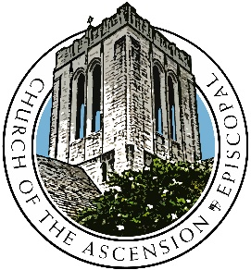
After completing your pledge card please send the file to tracy@coascension.org. Thank you!
At The Episcopal Church of the Ascension, we believe in sharing love and grace with God and one another.
Almighty God, maker of heaven and earth, inspire your people by your creative vision in the growing of your church, that we may partner with you and one another to share in The Way, The Truth, and The Life.
Amen.
Name: Click or tap here to enter text.
Address: Click or tap here to enter text.
Phone: Click or tap here to enter text.
Email: Click or tap here to enter text.
Capital Campaign Pledge
I/we pledge $Click or tap here to enter text. I/We plan to fulfill this pledge
☐ weekly, ☐ monthly, ☐ semiannually, ☐ yearly, ☐ other Click or tap here to enter text.
To be paid over ☐ one year, ☐ two years, ☐ three years, ☐ four years, ☐ five years

